COMPUTING
"Whether you want to uncover the secrets of the universe, or you want to pursue a career in the 21st century, basic computer programming is an essential skill to learn."

Stephen Hawking
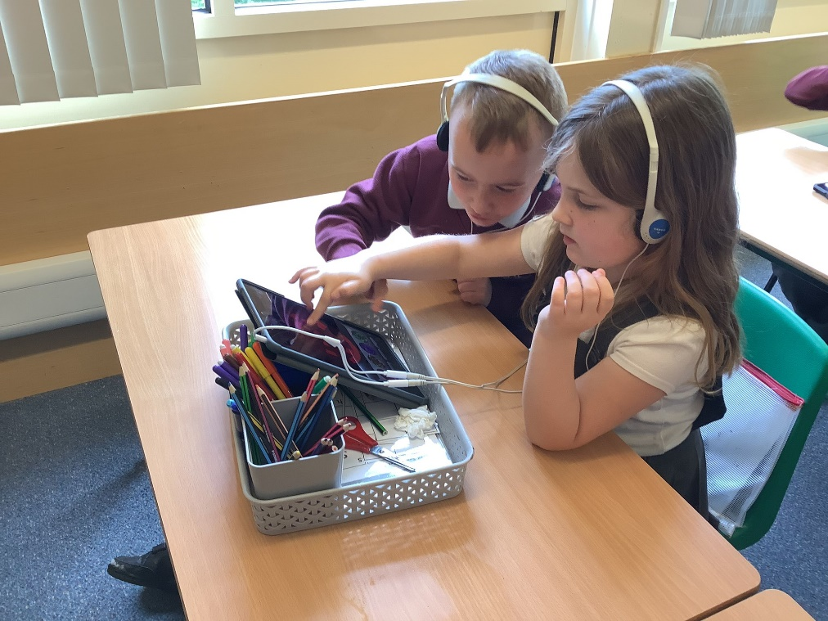
Select, Ctrl and Click on the policy and progression maps below for more details
Computing Progression Map
Assessment Tracker - Year 1
Assessment Tracker - Year 2

