GEOGRAPHY
‘You can travel the seas, poles and deserts and see nothing. To really understand the world, you need to get under the skin of the people and places. In other words, learn about geography. I can’t imagine a subject more relevant in schools. We’d all be lost without it.’
Michael Palin
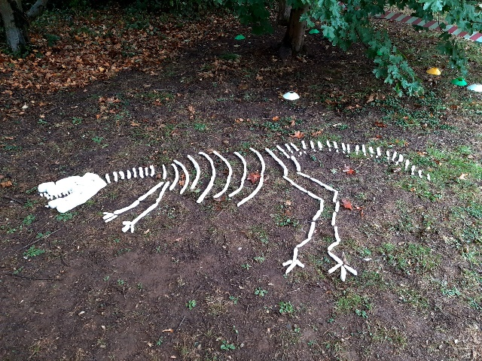
Select, Ctrl and Click on the policy and progression maps below for more details
Geography Policy
Assessment Tracker - Year 1
Assessment Tracker - Year 2

This page is still being updated

