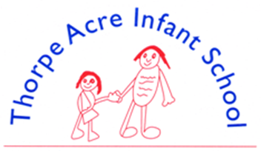

SCIENCE
‘Science knows no country, because knowledge belongs to humanity, and is the torch that illuminates the world.’
Louis Pasteur
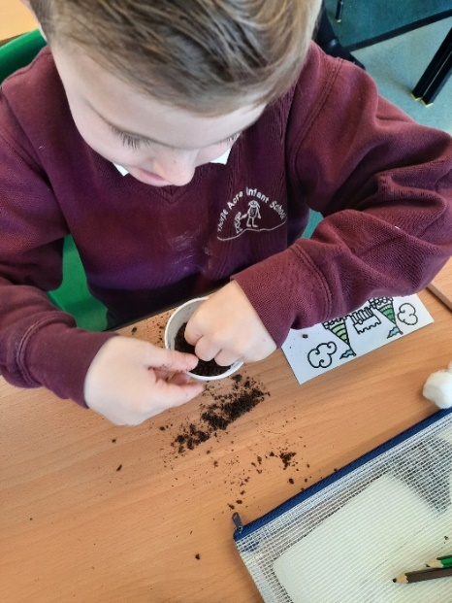
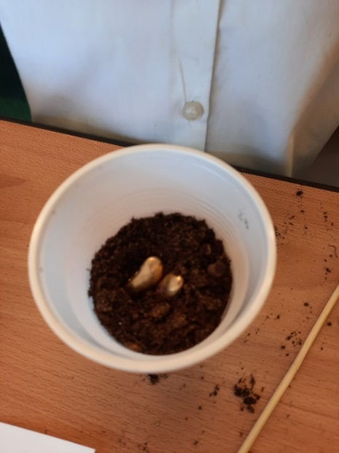

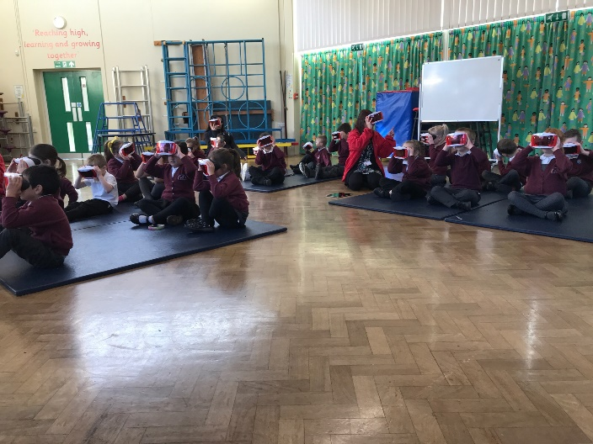

Select, Ctrl and Click on the policy and progression maps below for more details
Science Policy
Science Skills Progression Map

SCIENCE
Assessment Tracker - Animals - Year 1
Assessment Tracker - Everyday materials - Year 1
Assessment Tracker - Humans - Year 1
Assessment Tracker - Plants - Year 1
Assessment Tracker - Working Scientifically - Year 1
Assessment Tracker - Seasonal Changes - Year 1
Assessment Tracker - Animals including Humans - Year 2
Assessment Tracker - Everyday Materials - Year 2
Assessment Tracker - Living things in the environment - Year 2
Assessment Tracker - Plants - Year 2
Assessment Tracker - Uses of Everyday Materials - Year 2
Assessment Tracker - Working Scientifically - Year 2

