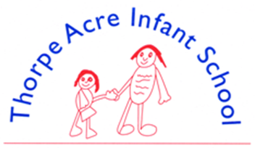

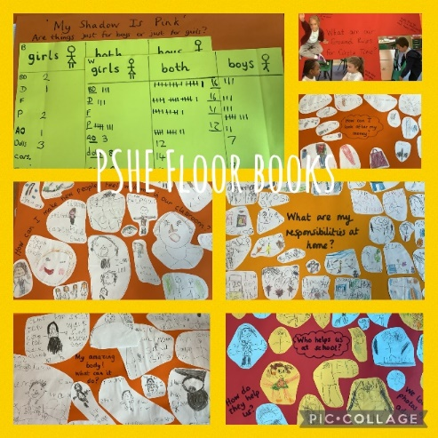
P.S.H.E
‘A curriculum for life’
PSHE Association

It is important for pupils to have opportunities to reflect on their learning and this will be built into lessons. Teachers will consider what learning has taken place, be able to demonstrate progress, and identify future learning needs for their class as well as individual pupils.
Each Year group has a ‘floor book’ where examples of work, thoughts, ideas and progress are recorded. These floor books are available for the children to reflect on; building a picture of developing skills and attributes, as the pupils get older. The floor book contains children’s work, drawings and photographs of activities completed in relation to the topic. Quotes are added to reflect the children’s comments during tasks.
At the beginning of each PSHE unit pupils will be challenged to answer a question which will be explored in the floor book throughout the topic. At the end of the unit, pupils will have the opportunity to revisit the question and add new knowledge/answers that they have gained. They then have the opportunity to discuss what they know now with each other.
As a maintained primary-phase school we must provide relationships education to all our pupils. Although, we are not required to provide sex education, we do need to teach the elements of sex education contained in the Science curriculum.
In an ever–changing world, it is important that children, at an age appropriate level, develop:
- Feelings of self-respect; confidence and empathy
- An understanding of the importance of health and hygiene
- Positive friendships.

Select, Ctrl and Click on the policy below for more details
PSHE Citizenship Policy
PSHE Skills Development Grids

