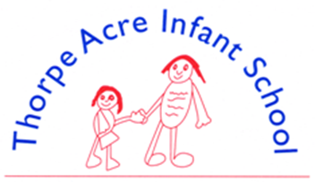

ENGLISH – READING & PHONICS
‘Reading and writing float on a sea of talk’
James Britton
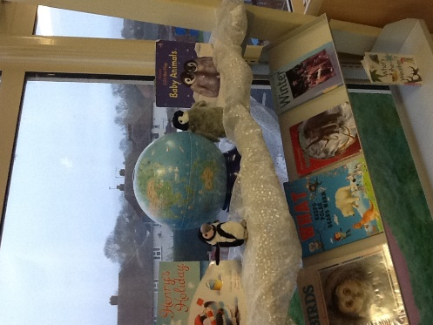
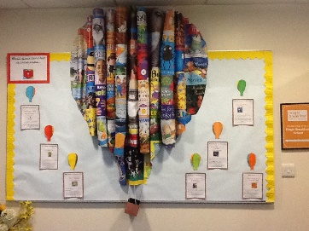
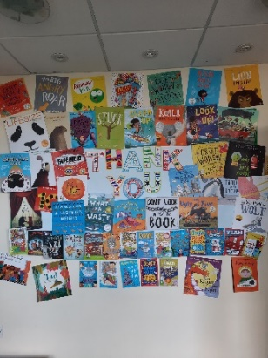
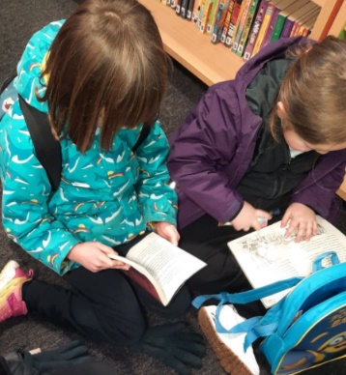

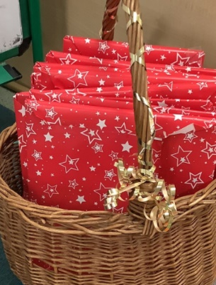
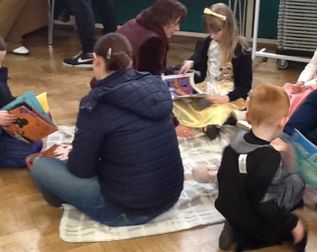
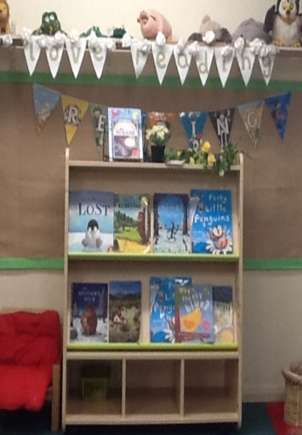

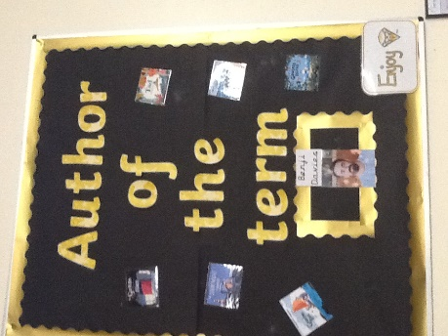

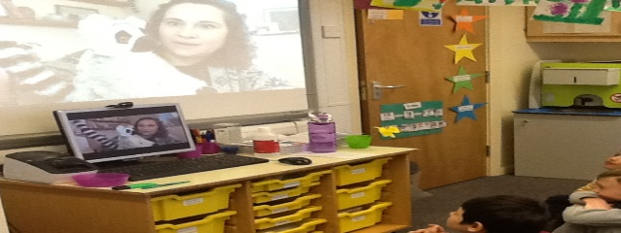

At Thorpe Acre Infants, we want to give the children a chance to build a ‘love’ for reading from an early age, which will make them life-long readers. Through this reading, our children are given the opportunities to develop culturally, emotionally, socially and spiritually.

Control & click on the documents below to access
Reading for Pleasure Policy
Reading Policy
Reading Progression Map
Phonics Assessment Tracker
Phonics Progression Map
Guided Reading
Library
Reading Newsletter
100 Books to Read in Key Stage 1
PHONICS
Children who read regularly or are read to regularly have the opportunity to open the doors to so many different worlds!
More importantly, reading will give your child the tools to become independent life-long learners. We want your child to love reading – and to want them to read for themselves. This is why we put our efforts into making sure they develop a love of books as well as simply learning to read.
We can achieve this together through:
- Read Write Inc, a program to help to your child read at school
- Encouraging children to develop a love of books by reading to them daily, at home and at school
- Giving children access to a wide range of books at school and at home

At Thorpe Acre Infants we use Read Write Inc Phonics (RWI) to give your child the best possible start with their Literacy development. Mrs Richards is our Read Write Inc lead teacher, so if you have questions about RWI, contact school who can refer you to her.

In Year 1 and 2 your child’s reading is assessed against national standards. Year 1 will sit their Phonics screening check and Year 2 will sit their national Key Stage 1 SATs.
​
Please access the resources below should you wish to know more. information below provides you with information about RWI and also useful websites and links to use with your child.
Phonics Resources and Useful Links
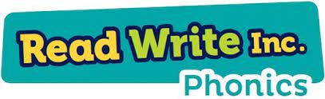
Control & Click on the image to purchase set 1 sound cards

Control & Click on the image to purchase the set 2 and 3 sound cards
Link to PhonicsPlay - Resources
Read, Write Inc Parents Information Document
Red Word List
Phonics Screening
Fred Talk
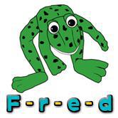
We use pure sounds (‘m’ not’ muh’,’s’ not ‘suh’, etc.) so that your child will be able to blend the sounds into words more easily.
At school we use a puppet called Fred who is an expert on sounding out words! we call it, ‘Fred Talk’. E.g. m-o-p, c-a-t, m-a-n, sh-o-p, b-l-a-ck.
The following video is an example of pronouncing pure sounds
www.youtube.com/watch?v=TkXcabDUg7Q

The following video is an example of blending sounds with Fred. https://www.youtube.com/watch?v=dEzfpod5w_Q

We provide children with a range of opportunities to support their learning at home through the use of resources such as Bug Club.

