## 

## HISTORY

***‘A people without the knowledge of their past history, origin and culture is like a tree without roots’.***

Michael Garvey

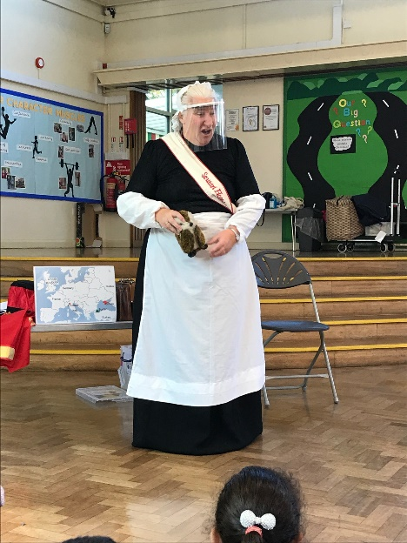

**Select, Ctrl and Click** on the policy and progression maps below for more details

[History Policy](http://tais.leics.sch.uk/Uploads/Documents/Curriculum%20-%20NEW%20SEPTEMBER%202021/History/History%20Policy.pdf)

[History Skills Progression Map](http://tais.leics.sch.uk/Uploads/Documents/Curriculum%20-%20NEW%20SEPTEMBER%202021/History/Skills%20development%20History%20July%202021.pdf)

[Assessment Tracker - Year 1](http://tais.leics.sch.uk/Uploads/Documents/Curriculum%20-%20NEW%20SEPTEMBER%202021/Assessment%20Trackers/HISTORY%20Year%201.docx)

[Assessment Tracker - Year 2](http://tais.leics.sch.uk/Uploads/Documents/Curriculum%20-%20NEW%20SEPTEMBER%202021/Assessment%20Trackers/HISTORY%20YEAR%202.docx)

At Thorpe Acre Infant School we aim to excite and enthuse the children’s interest in the past. As historians, they will begin to piece together the narrative of time and its impact on our country, and the wider world today.

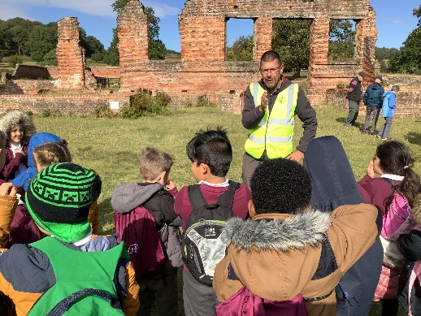

Children have the opportunity to extend their knowledge outside of the classroom by going on educational visits to a range of different local places, such as Bradgate Park. This particular visit allowed the children to see a part of Lady Jane Grey’s life whilst also giving them the chance to ask the experts some questions. From sketching and exploring the ruins of her once home, to seeing the execution block; the children had a wonderful day where their inquisitive minds were able to run free.

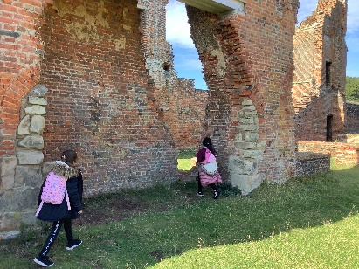

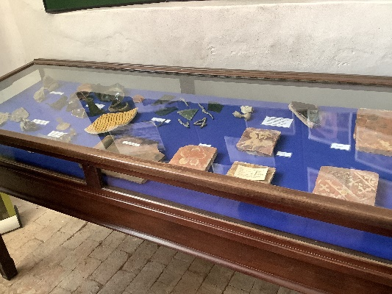

History experts are invited in to help the children step back in time with the use of a range of artefacts and storytelling. We teach children to make comparisons between ‘then’ and ‘now’, looking at the similarities and differences.

