MUSIC
‘Without music, life would be a mistake.’
Friedrich Nietzsche

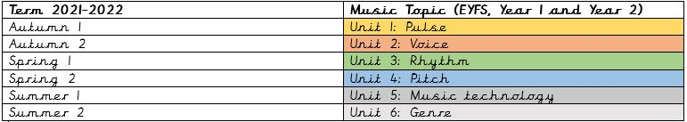
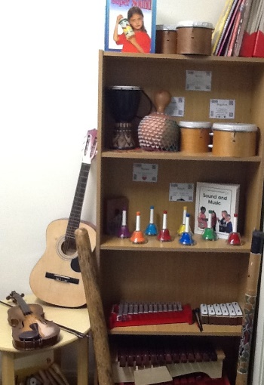
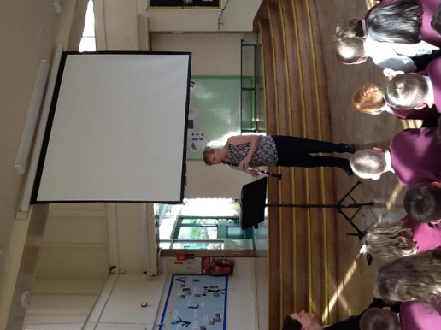
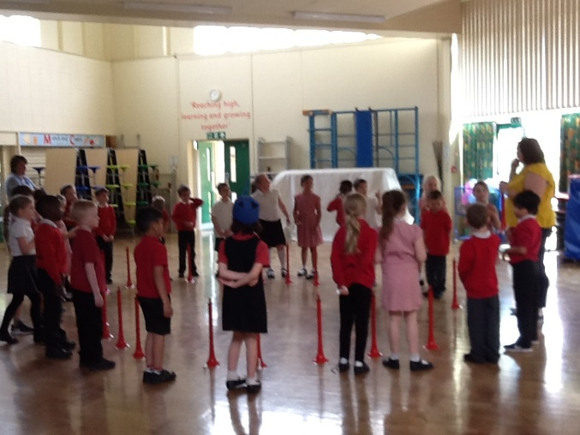

We follow the Leicestershire Music Scheme. Each teacher has a file of plans, resources and assessment materials.
Select, Ctrl and Click on the policy below for more details:
Music Policy
Skills Development Grids
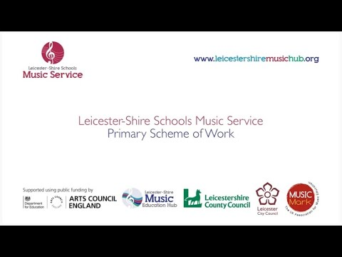
Click on the video above to learn about the Leicestershire Music Scheme
EYFS - Unit 1 Assessment Sheet
Year 1 - Unit 1 Assessment Sheet

Year 2 - Unit 1 Assessment Sheet
EYFS - Unit 2 Assessment Sheet
Year 1 - Unit 2 Assessment Sheet
Year 2 - Unit 2 Assessment Sheet
EYFS - Unit 3 Assessment Sheet
Year 1 - Unit 3 Assessment Sheet
Year 2 - Unit 3 Assessment Sheet
EYFS - Unit 4 Assessment Sheet
Year 1 - Unit 4 Assessment Sheet
Year 2 - Unit 4 Assessment Sheet
EYFS - Unit 5 Assessment Sheet
Year 1 - Unit 5 Assessment Sheet
Year 2 - Unit 5 Assessment Sheet
EYFS - Unit 6 Assessment Sheet
Year 1 - Unit 6 Assessment Sheet
Year 2 - Unit 6 Assessment Sheet

