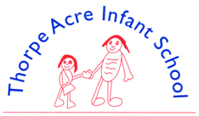

Alan Moss Road, Loughborough, Leicestershire LE11 4SQ
Telephone: 01509 212021 Email: office@tais.leics.sch.uk
Website: www.tais.leics.sch.uk
Executive Headteacher: Ms J Beaumont
Deputy Headteacher: Miss K Henson

We need your help!
Can you help?
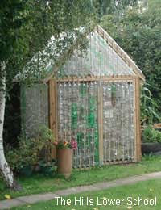
We are hoping to create a DIY, eco-friendly green house!
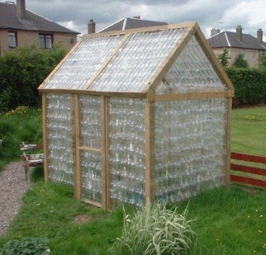

What we need?
We need as many 2ltr plastic bottles as we can get!
We will be collecting them to try and create as big a greenhouse as we can!

Why?
To help the children to understand the benefits of recycling rather than throwing away, along with developing a useful place to support the growing of our very own fruit or vegetables.

We have been busy setting up our vegetable garden and need a greenhouse for the children to start planting their own seeds and watch them grow.

We want them to experience how our food is grown and to get to know how they can create a great crop of fruit or vegetables.

Please drop any empty 2L bottles into school so we can start collecting, ask family and friends to collect too!

Thank you for your support in advance.

