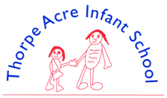

Alan Moss Road, Loughborough, Leicestershire LE11 4SQ
Telephone: 01509 212021 Email: office@tais.leics.sch.uk
Website: www.tais.leics.sch.uk
Executive Headteacher: Ms J Beaumont
Deputy Headteacher: Mrs C Shaw

Wednesday 6th December 2023
Dear Parents/Carers,

Christmas Fair – Thursday 21st December

During the school day on Thursday 21st December we will be holding a Christmas Fair for the children in order to raise money to look after the school rabbits. All money raised will go towards their food and medical care.

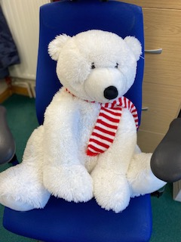
The following items will be on sale:
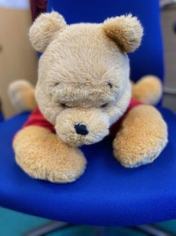
- Cakes
- Keyrings
- Birdfeeders
- Glitter tattoos
- Christmas playdoh
- Chocolate chip fudge

There will also be a “Guess the Name of the Polar Bear” competition, and a raffle to win “Winnie the Pooh”.

Everything is 50p per item. Please send money in a named envelope, purse or wallet. If there are any items left we will sell them from the Hall at the end of the day.

We need your written permission if your child chooses to have a glitter tattoo. Please return the slip by Friday 15th December at the latest. If you would like to view the ingredients, please come to the school office. Thank you for supporting this event.

Yours sincerely,

Mrs C Shaw
Deputy Headteacher
**********************************************************************************************

I give permission for my child ………………………..……………….. in ………………….. Class to have a glitter tattoo at the Christmas Fair on 21/12/23.

Signed…………………………………………… Name………………………………………
By signing you are confirming that you have Parental Responsibility for the child.

